Proyecto
The Social Process of Guarantees of Antioquia, Colombia, an experience of unarmed civil protection with indigenous and peasant communities of Bajo Cauca.

During the months of May, June and July, the research team visited the territories of Tarazá, Cáceres and El Bagre, where meetings were held with the Almendros 2 Indigenous Community, the Senú Indigenous Community and the Embera de Cáceres People. In each space, work was done with authorities of the ethnic communities, as well as with the Indigenous Guard and women's groups; It was also shared with the leaders of the organizations: Peasant Association of Bajo Cauca - ASOCBAC, Association of Agroecological Brotherhoods of Guamocó - AHEREMIGUA and Association of Environmental Victims of Puerto Clavel, ASOVIAMCLA.
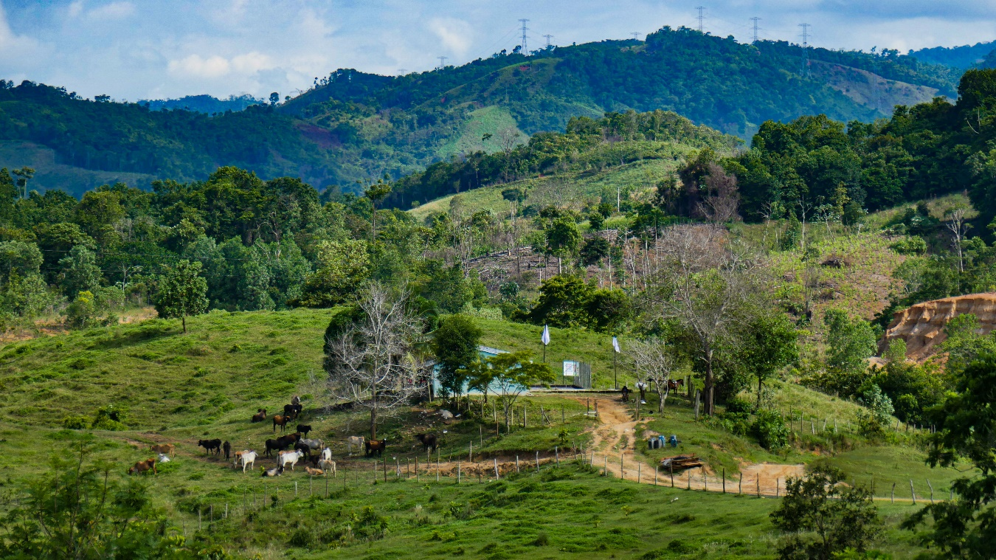
Humanitarian shelters to defend life, Buenos Aires Bajo village, Tarazá 2023
Word circles
During the visits, 12 circles of the word were carried out, whose purpose was "to deepen the information on the protection and self-protection strategies planned and executed by the ethnic communities and peasant organizations, and the results they have obtained, recognizing the individual and collective practices , motivations and lessons learned”.
Three meetings were held with peasant organizations; with the Senú (Cáceres el Bagre) and Embera people, 9 spaces were developed. In each circle of the word, there was participation of women leaders, indigenous guard women and women with positions of political authority within the reservations (Resguardos).

As a result of this process, the following stand out:
1) In all circles of the word, reflection was made on how self-protection strategies are executed within organizations, giving rise to evaluating individually and collectively the commitment that one has with the self-protection protocol that they have.
2) There was a discussion about the role of women in the organizational spaces, indigenous guards and authorities in the reservations, it is highlighted that women have been gaining spaces and representation, but obstacles and risks persist for the exercise of their leadership, for That is a challenge to get many more women from the territories to participate in organizational and political actions, in addition to making progress in the fight against discrimination and patriarchal violence.
3) the existence of the indigenous guard is positively valued, which has not only been a strategy for ethnic communities, but also for peasant territories, in addition to highlighting the work that has been done with the guard nurseries, especially in the Indigenous Community Almendros 2 where there is evidence of an appropriation by children and adolescents by the indigenous guard. Especially in contexts where the population is more vulnerable to recruitment, use and use by armed groups, they are adolescents and young people.
4) in order to remain in the territory, exercise their leadership and build territorial peace, it has been necessary to articulate with other organizations and processes, the Social Process of Guarantees stands out, as a space that has allowed self-protection for leaders and to generate dialogue with the Colombian State.
Content creation for multimedia creations
One of the interesting challenges of the investigation is what concerns artistic creation, for this reason three exercises were developed that combined the sound, graphic art, writing and audiovisual; implementing cartographic techniques, collage, exquisite corpse (plays on words and images), photographic and sound recording, testimonial exercises and landscape videos, in order to have enough information for the creation of a multimedia tool that compiles memories, experience and accumulated protection and self-protection from various formats.
This is how two tours were carried out in the municipality of Tarazá, where ASOCBAC shared, together with the communities of the village of La Unión and Buenos Aires Bajo, the strategy of Humanitarian Shelters, where these two experiences were recorded, which they promoted in the territory to protect the life of the communities, in addition, testimonies of leaders were recorded.
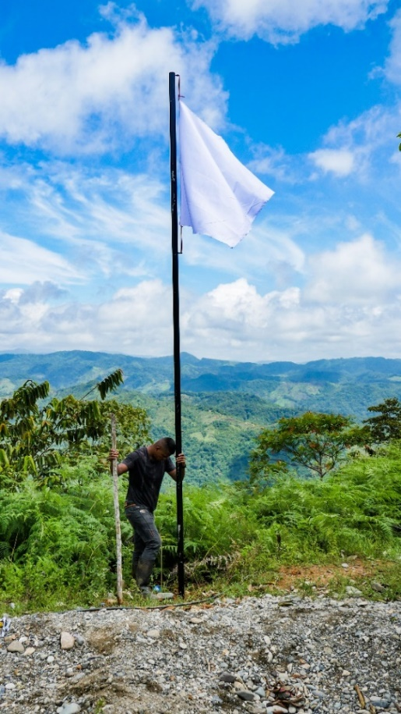
Installation of white flags, by ASOCBAC vereda la Unión, Tarazá 2023
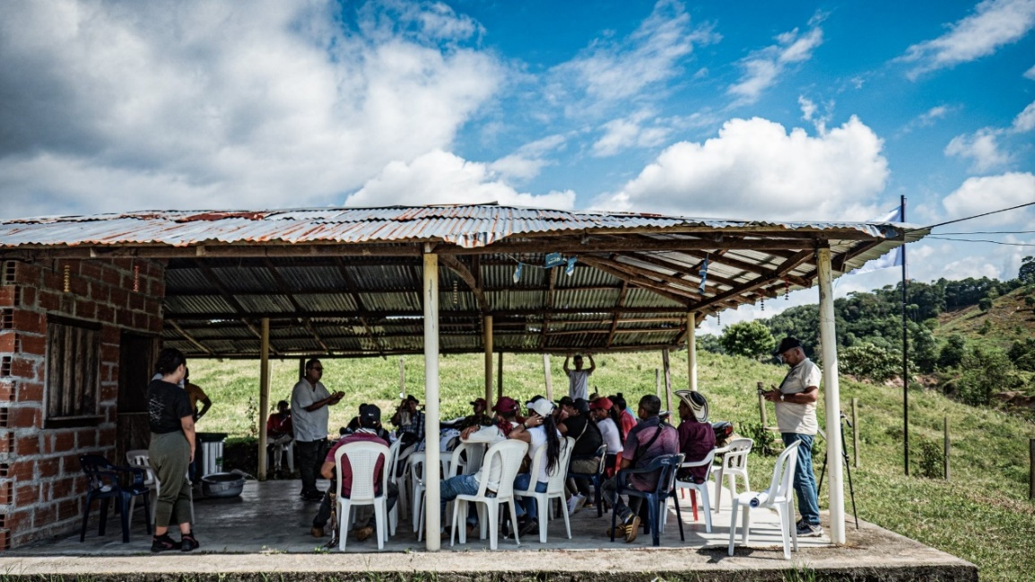
Installation of white flags, by ASOCBAC vereda la Unión, Tarazá 2023

Acknowledging the strategy of ASOCBAC, on Humanitarian Shelters to defend life, village Buenos Aires Bajo, Tarazá 2023
For its part, in the municipality of Cáceres with the Senú and Embera Indigenous Communities, a visit was made to one of the reservations, where together with ethnic and spiritual authorities through a guided harmonization process, it was possible to recognize the physical elements, of nature, symbolic and spiritual that communities use to protect themselves from the armed violence that subsists in the municipality.

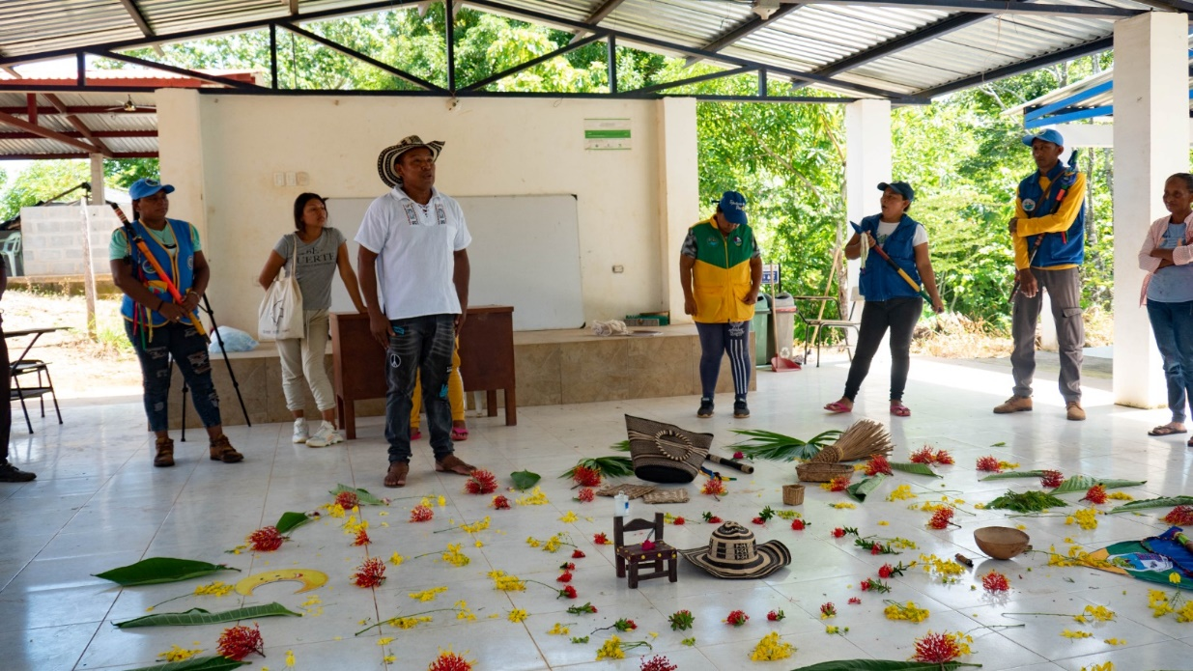
Space for spiritual harmonization in Puerto Belgium, Cáceres with Senú and Embera Indigenous Communities 2023
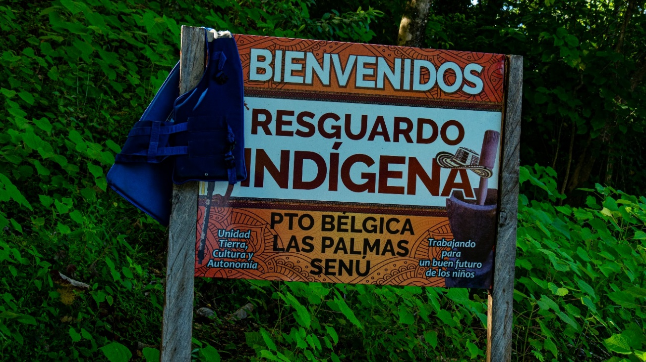
Territorial tour in Puerto Bélgica, Cáceres with the Senú and Embera indigenous communities. 2023

In the same way, two visits were made to the municipality of El Bagre, where they traveled with the Almendros 2 Community, their shelter accompanying them, in the installation of white flags as a symbol of peace and strategy of demarcation of the territory so that legal and illegal armed actors do not enter.
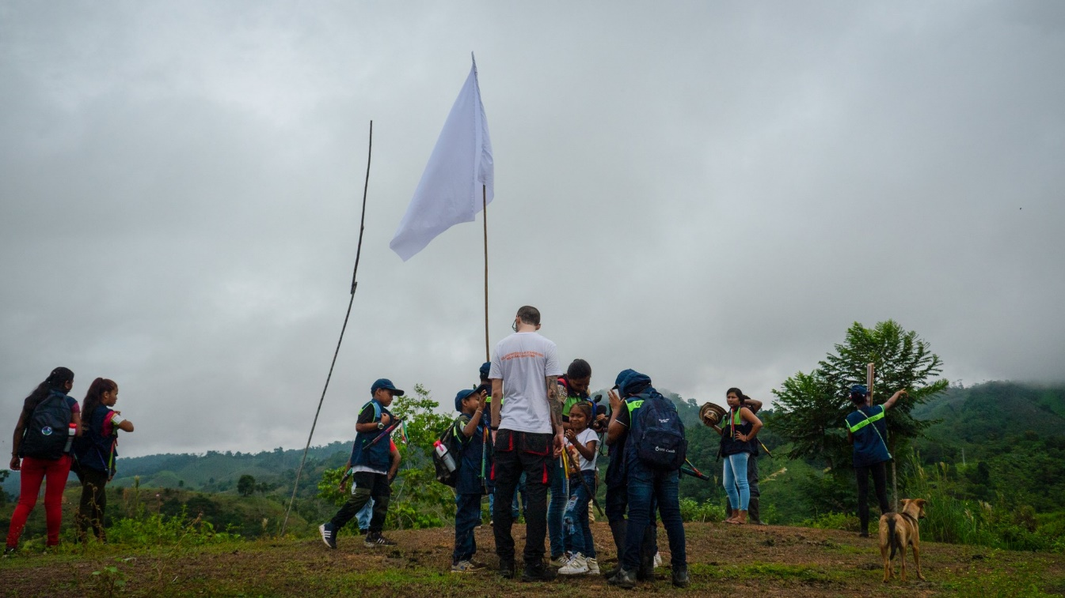
Installation of white flags, by the indigenous guard of the Almendros 2 Community, El Bagre 2023
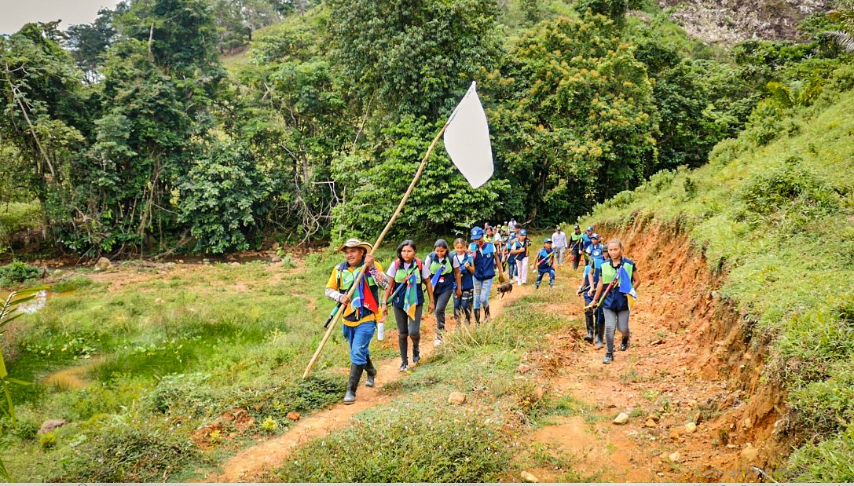
Walk for the installation of white flags, by the indigenous guard of the Almendros 2 Community, El Bagre 2023

Likewise, the work of the indigenous guard was registered, managing to document its process as a mechanism of self-protection of the community, but also to share expectations regarding the future of the territory. During this visit, it was also possible to work with a group of women from the community who shared their organizational experience through collective recordings.
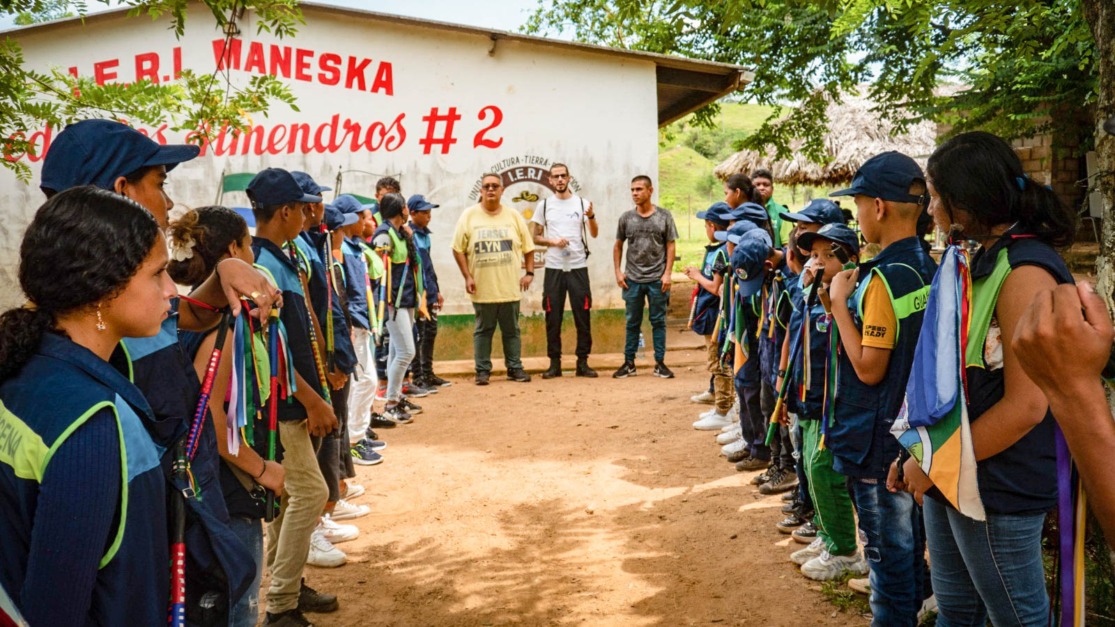
Recognizing the indigenous guard as a mechanism for self-protection of life and territory, Los Almendros 2 Indigenous Community, El Bagre 2023
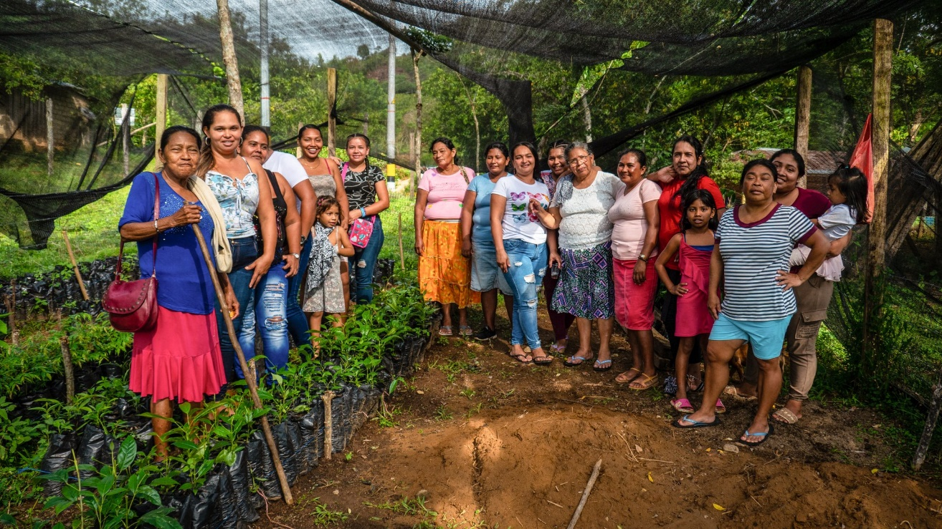
Group of women leaders of the Almendros 2 Indigenous Community, El Bagre 2023

In the second round, the strategy of the Humanitarian Refuge was documented as a common place that has served for indigenous residents and peasants to take refuge in moments of combat by armed actors or in other risk situations.
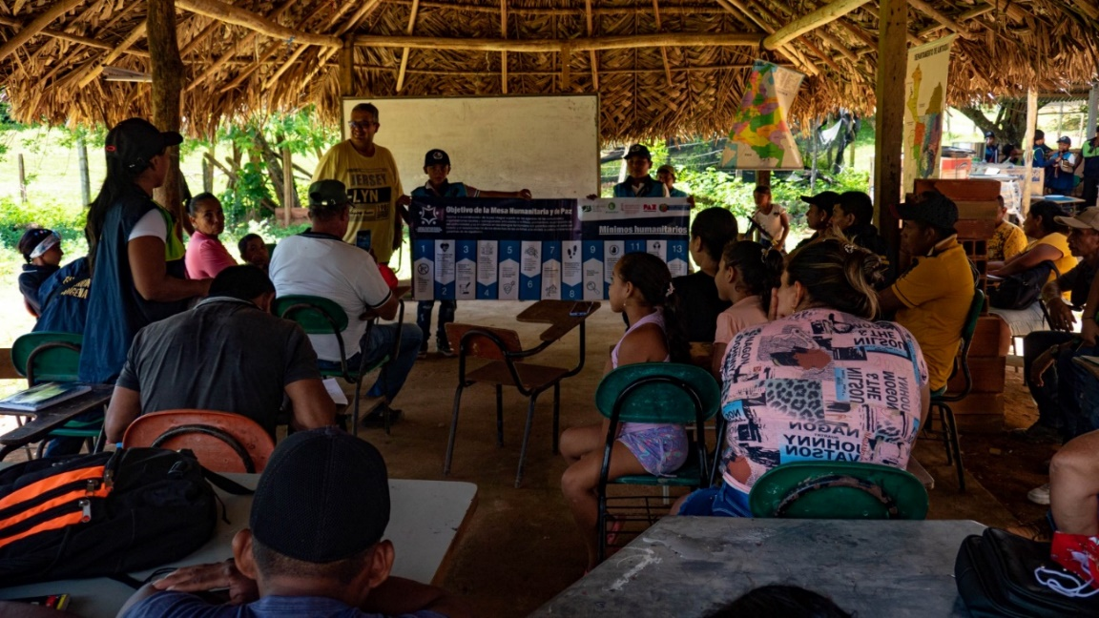}
Recognizing the strategy of Humanitarian Shelters to defend life, Los Almendros 2 Indigenous Community, El Bagre 2023
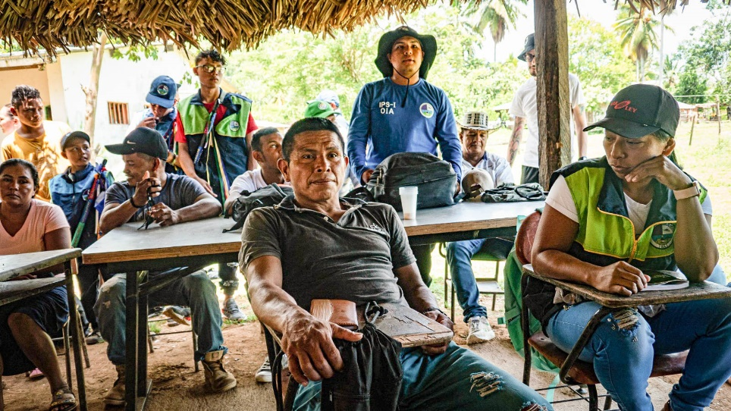
Recognizing the strategy of Humanitarian Shelters to defend life, Los Almendros 2 Indigenous Community, El Bagre 2023

For the month of August, it is expected to conduct interviews with State officials who have the constitutional duty to protect leaders and communities, in addition to ending the topic of artistic creations with the Social Process of Guarantees.

Investigadores. Astrid Torres, Eberhar Cano y Winston Gallego. En la creación de piezas fotografías y audiovisuales: Juan Esteban Prado

